Marathwada Shikshan Prasarak Mandal’s

**Deogiri Institute of Engineering and Management Studies,**

**Aurangabad**

**Seminar Report**

**On**

**Skin Care Recommendation System**

Submitted By

**Harshada Limbekar (36118)**

**Dr. Babasaheb Ambedkar Technological University**

**Lonere (M.S.)**



Department of Computer Science and Engineering

**Deogiri Institute of Engineering and Management Studies,**

**Aurangabad**

(2019- 2020)

**CERTIFICATE**

This is to certify that the Seminar entitled “**Skin Care Recommendation System**” submitted by **Harshada Limbekar** is a bonafide work completed under my supervision and guidance in partial fulfillment for the award of Bachelor of Technology (Computer Science and Engineering) Degree of Dr. Babasaheb Ambedkar Technological University, Lonere.

Place: Aurangabad

Date:

**Mr. Pankaj Durole Sir Mr. S.B. Kalyankar**

**Guide Head**

**Dr. Ulhas D. Shiurkar**

**Director,**

**Deogiri Institute of Engineering and Management Studies,**

**Aurangabad**

**Abstract**

As we all are aware about the pollution and its adverse effect on the skin. Practically if there is one pimple on our skin, we cannot go to the dermatologist and skin therapist. What to do in that situation. Hence I am here with the problem solution. Skin care recommendation app will help you to get direct medication at home only

Skin care is the range of practices that support skin integrity, enhance its appearance and relieve skin conditions. They can include nutrition, avoidance of excessive sun exposure and appropriate use of emollients. Practices which tells that enhance appearance include the use of cosmetics, botulin, fillers, laser resurfacing, microdermabrasion, peels, retinol therapy. Skin care is a routine daily procedure in many settings, such as skin that is either too dry or too moist, and prevention of dermatitis and prevention of skin injuries.

Skin care is at the interface of cosmetics, and dermatology, a traditional medical discipline; there is some overlap with each of these topics.

###### Contents

**1. INTRODUCTION 5**

**2. LITERATURE SURVEY 6**

**3. MODULE 7-9**

**4. CONCLUSION 10**

**REFERENCES**

**ACKNOWLEDGEMENT**

**Introduction to Skin Care Recommendation System**

As a skincare products enthusiast, I often found myself spending quite some time sifting through reviews to find the ideal skincare product that suited my needs. While most skincare websites prominently display average ratings and reviews for products, the overall set of criteria to search for skincare products is not very robust. For instance, a search for a "orange-scented serum that is both cheap and moisturizing" can often lead to an exorbitant amount of hours of tedious reading through several non-informative reviews before a match is found.

To solve this issue, I decided to take advantage of the vast amount of text-based review data and NLP (Natural Language Processing) techniques to build a basic recommendation system for Skincare Products. My recommendation system uses TF-IDF to process review's text data and recommends products with the top 5 highest cosine similarity score. The website of choice to obtain the dataset for this project was  more specifically the section pertaining reviews for Face Products.

Dataset for the recommendation system will be the images of pimples and rashes etc.

## 

## Literature Review

[1] - Today, recommendation algorithms are widely used by companies in multiple sectors with the aim of increasing their profits or offering a more specialized service to their customers. Moreover, there are countless applications in which classification algorithms are used, seeking to find patterns that are difficult for people to detect or whose detection cost is very high. Sometimes, it is necessary to use a mixture of both algorithms to give an optimal solution to a problem. This is the case of the ADAGIO, a R&D project that combines machine learning (ML) strategies from heterogeneous data sources to generate valuable knowledge based on the available open data. In order to support the ADAGIO project requirements, the main objective of this paper is to provide a clear vision of the existing classification and recommendation ML systems to help researchers and practitioners to choose the best option. To achieve this goal, this work presents a systematic review applied in two contexts: scientific and industrial. More than a thousand papers have been analyzed resulting in 80 primary studies. Conclusions show that the combination of these two algorithms (classification and recommendation) is not very used in practice. In fact, the validation presented for both cases is very scarce in the industrial environment. From the point of view of software development life cycle, this review also shows that the work being done in the ML (for classification and recommendation) research and industrial environment is far from earlier stages such as business requirements and analysis. This makes it very difficult to find efficient and effective solutions that support real business needs from an early stage. It is therefore that the article suggests the development of new ML research lines to facilitate its application in the different domains

[2] - Recommender systems have become an important research field since the emergence of the first paper on collaborative filtering in the mid-1990s. Although academic research on recommender systems has increased significantly over the past 10 years, there are deficiencies in the comprehensive literature review and classification of that research. For that reason, we reviewed 210 articles on recommender systems from 46 journals published between 2001 and 2010, and then classified those by the year of publication, the journals in which they appeared, their application fields, and their data mining techniques. The 210 articles are categorized into eight application fields (books, documents, images, movie, music, shopping, TV programs, and others) and eight data mining techniques (association rule, clustering, decision tree, k-nearest neighbor, link analysis, neural network, regression, and other heuristic methods). Our research provides information about trends in recommender systems research by examining the publication years of the articles, and provides practitioners and researchers with insight and future direction on recommender systems. We hope that this paper helps anyone who is interested in recommender systems research with insight for future research direction.

**MODULE -**

**Working:**

* User can register to the app.
* Camera will be on.
* It will identify the problem area on the face.
* It will automatically detect the problem area on the face.
* It will recommend the skin care product he or she can use accordingly.

**Dataset:**

Dataset for the recommendation system will be the images of pimples and rashes etc.

When camera will detect the problem only images of problem area will directly go to the database so app can use it further.

**Technologies:**

* Machine learning
* Convolution neural network
* Decision making tree classifier
* Artificial intelligence

**Architecture:**

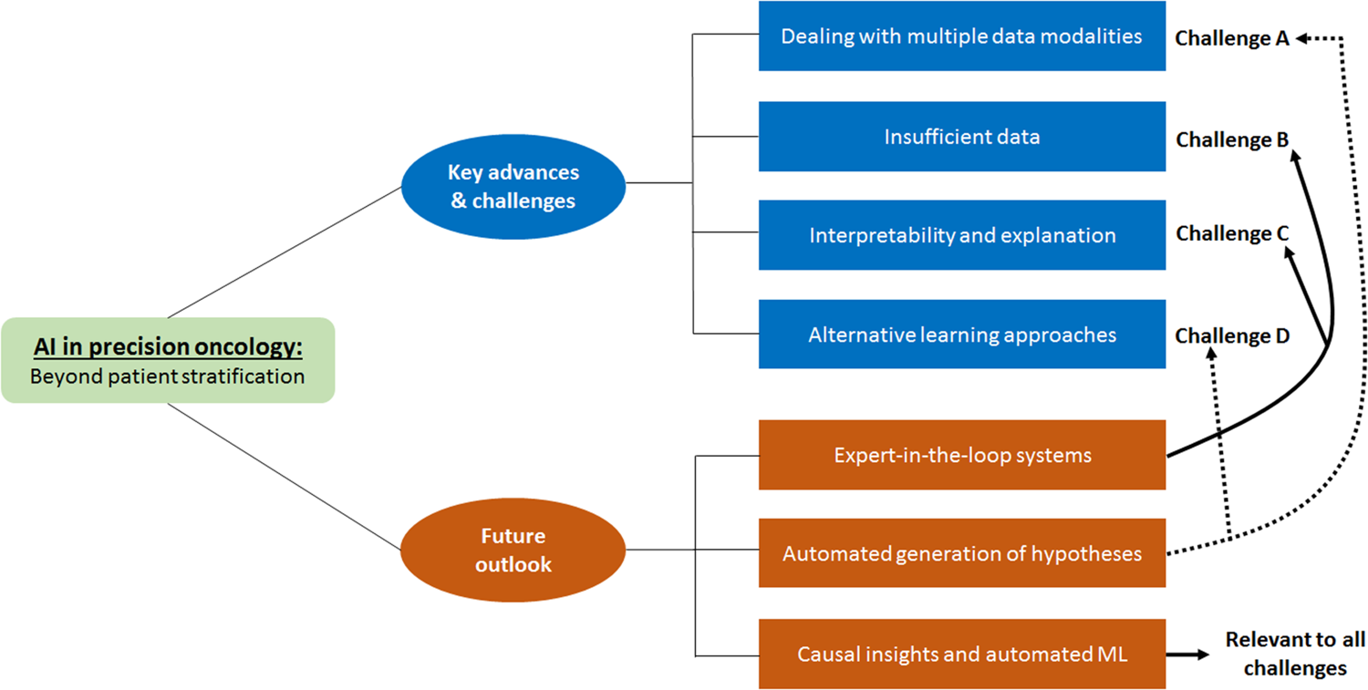

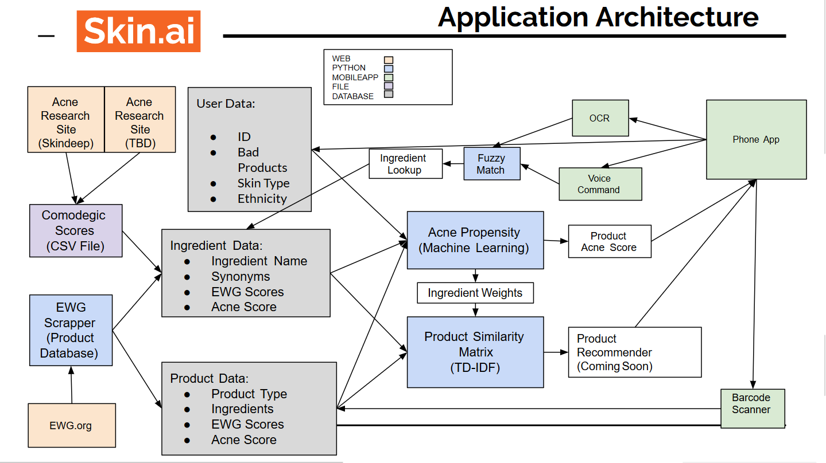

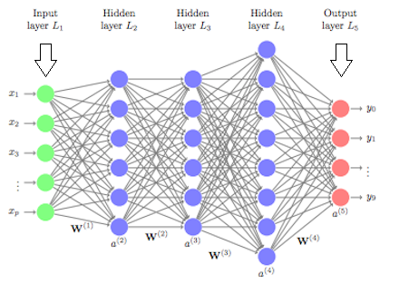

**CONCLUSION**

Hence Skin care Recommendation system will help the user to get proper medication for their skin issues by using their smartphones only. Skin Care Recommendation system will save the time of user and also helps for saving the money.

**REFERENCES**

[1]<https://www.hindawi.com/journals/sp/2019/8043905/>

[2]<https://www.researchgate.net/publication/257404071_A_literature_review_and_classification_of_recommender_systems_research_Expert_Systems_with_Applications_3911_10059-10072>

**ACKNOWLEDGEMENT**

I would like to place on record my deep sense of gratitude to Prof. Pankaj Durole Sir, HOD-Dept. of Computer Science and Engineering, Deogiri Institute of Engineering and Management Studies Aurangabad, for his generous guidance, help and useful suggestions.

I express my sincere gratitude to Prof. Sanjay Kalyankar, Dept. of Computer Science and Engineering, Deogiri Institute of Engineering and Management Studies Aurangabad, for his stimulating guidance, continuous encouragement and supervision throughout the course of the present work.

I am extremely thankful to Dr. Ulhas Shiurkar, Director, Deogiri Institute of Engineering and Management Studies Aurangabad, for providing me infrastructural facilities to work in, without which this work would not have been possible.

**Signature of Student**

Harshada Limbekar Sign